Week 0
ROLL NO: 241801310
Name: Vidhyashree.J
Q1)Calculate area and perimeter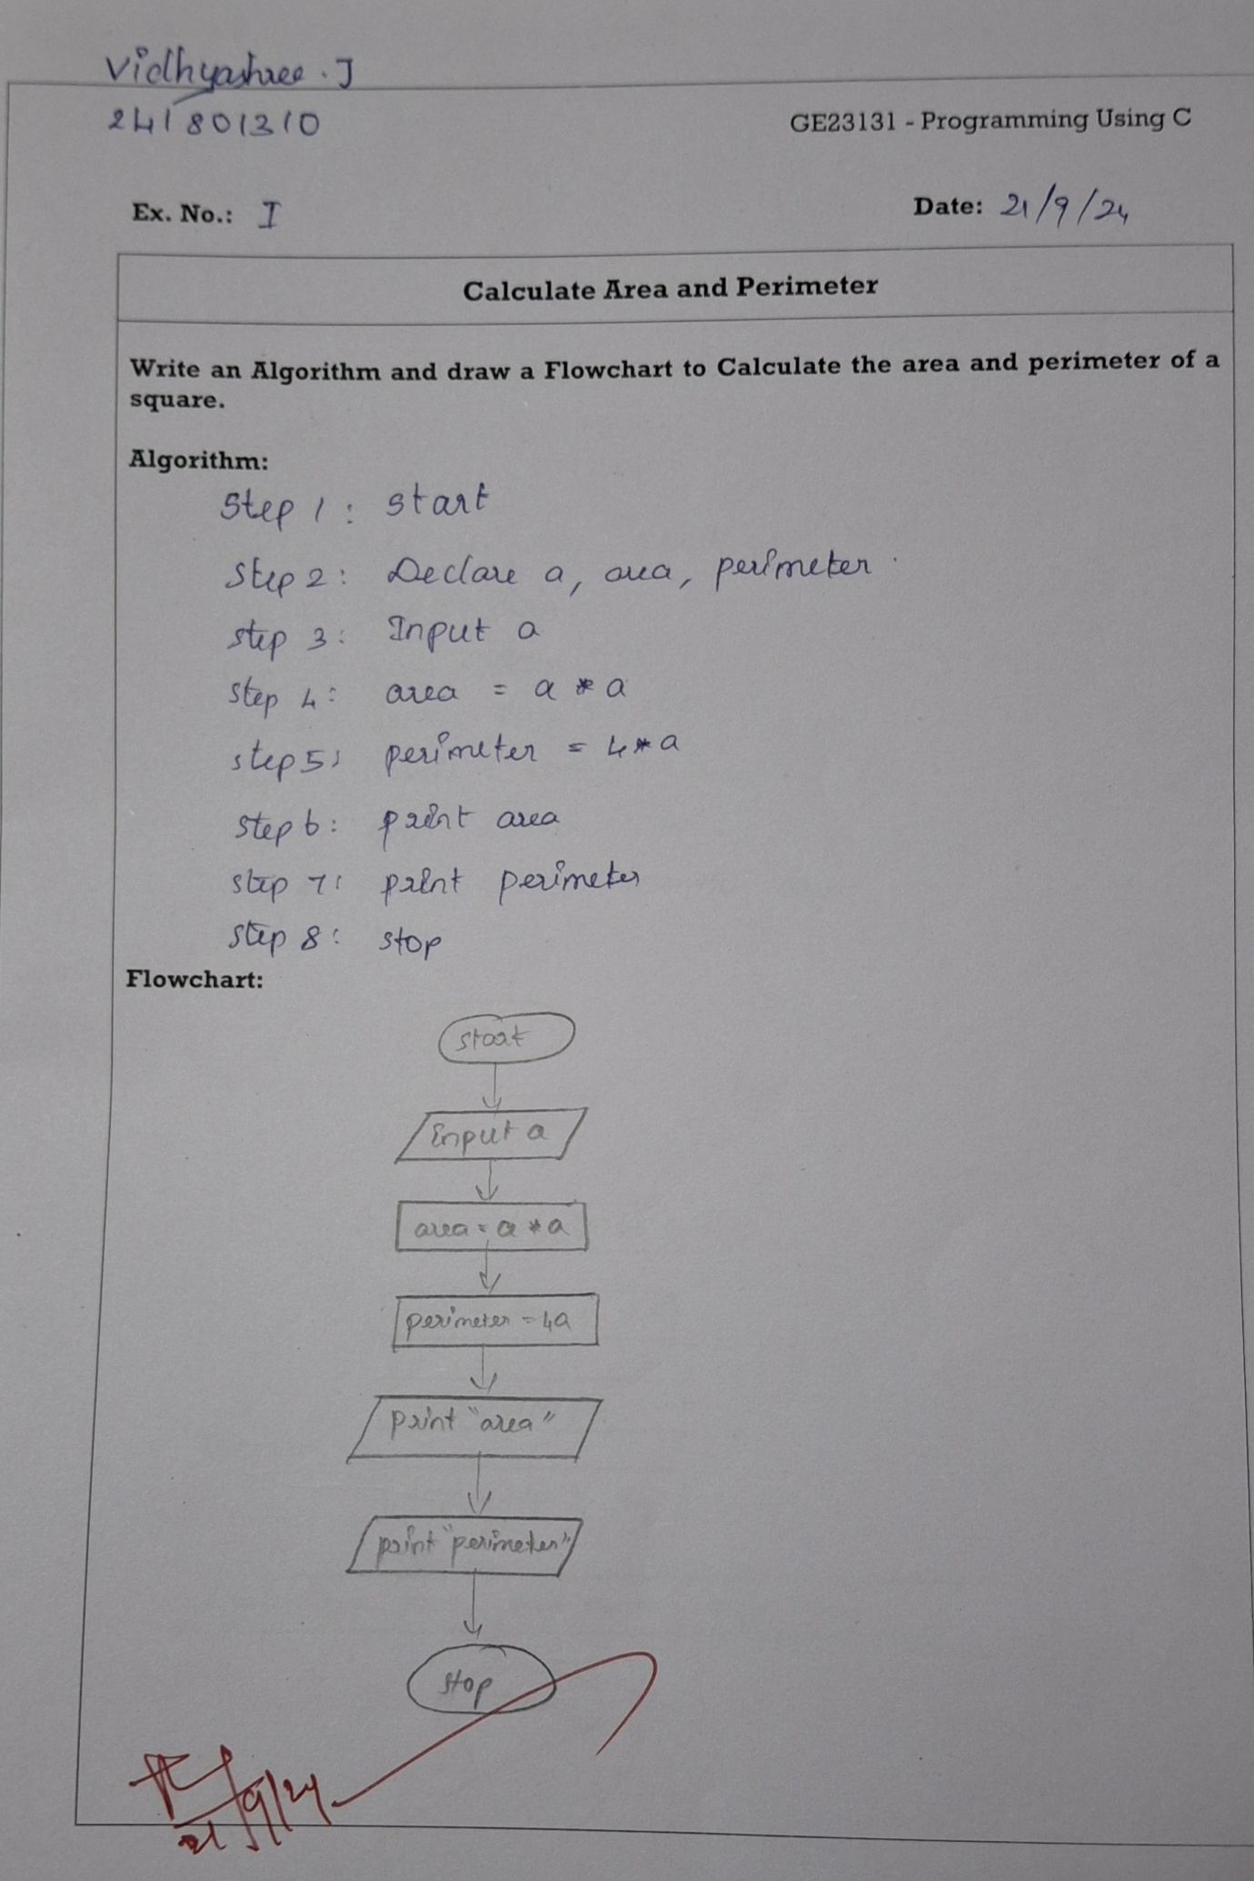
Q2)Day to year conversion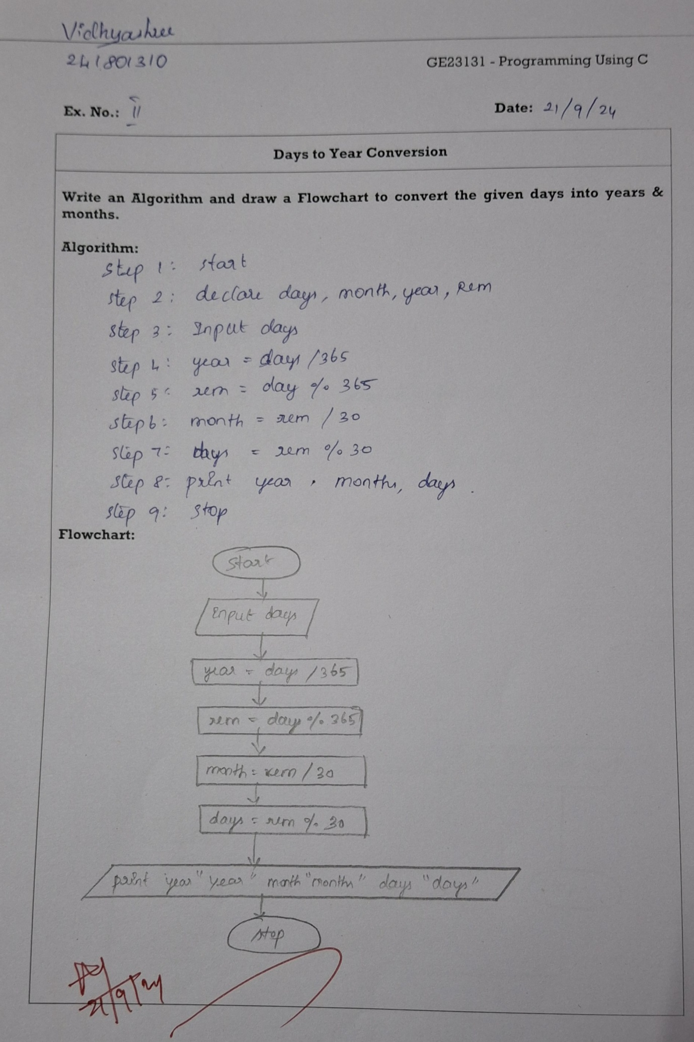
Q3) Prime number 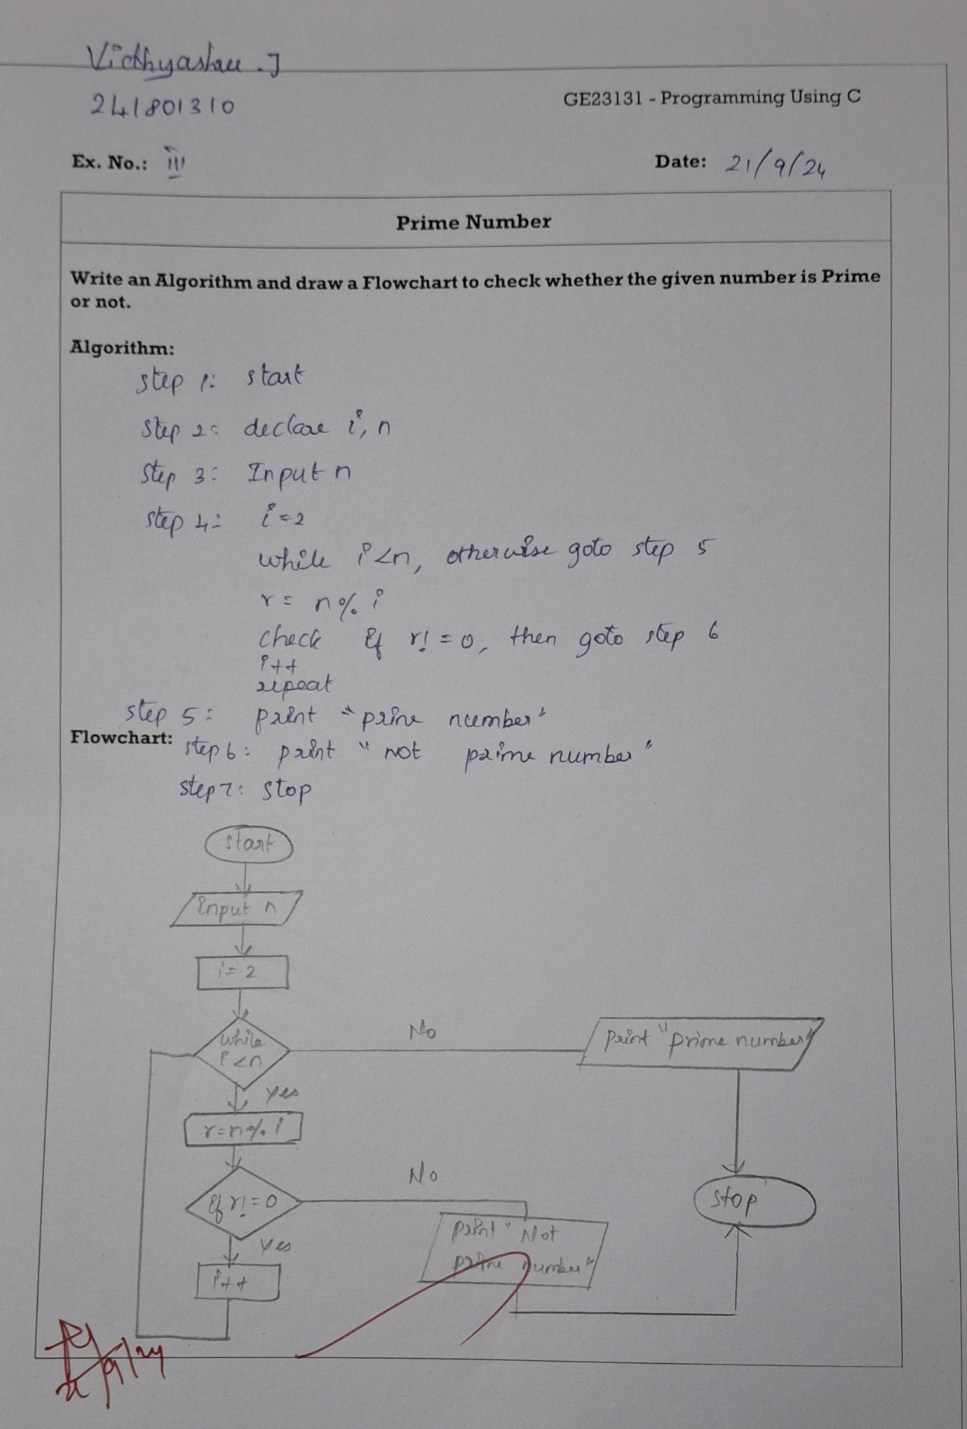
Q4)Leap year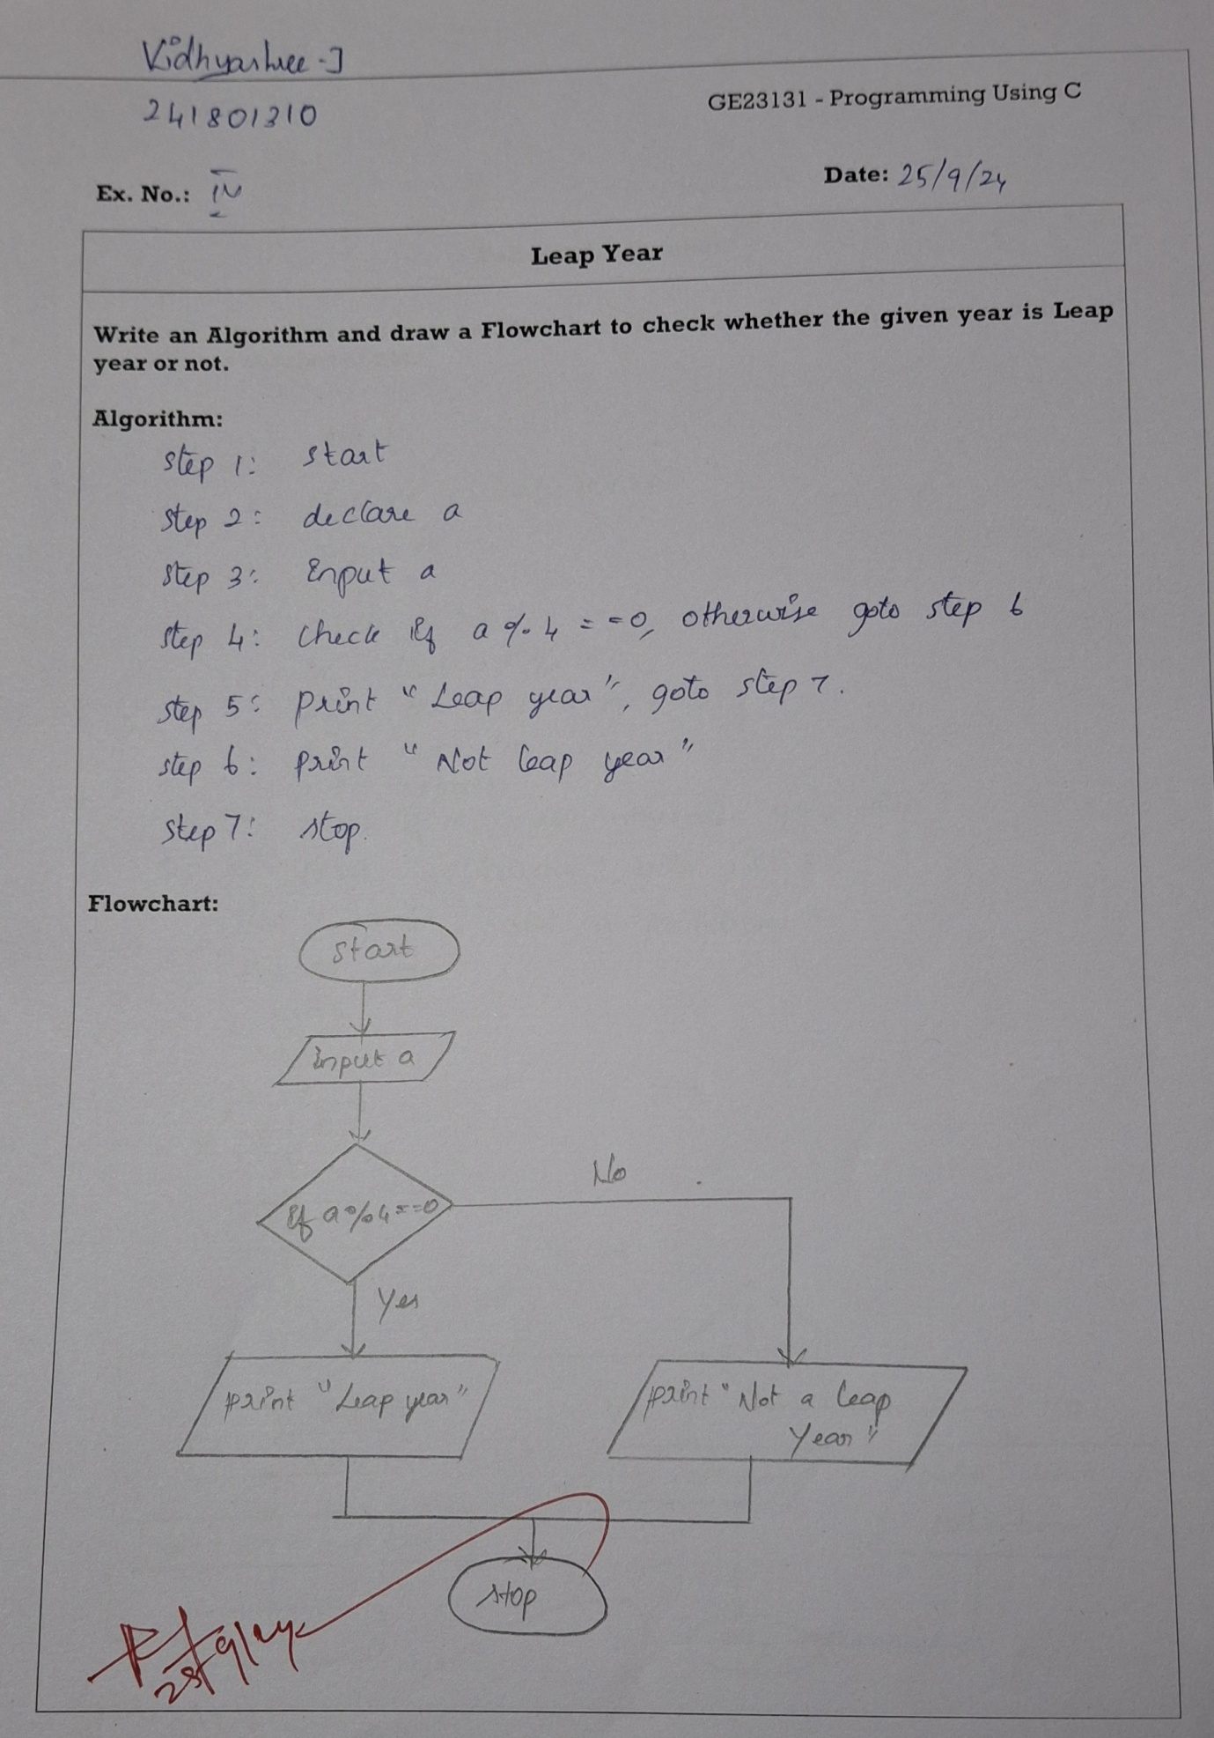

Q5)Palindrome number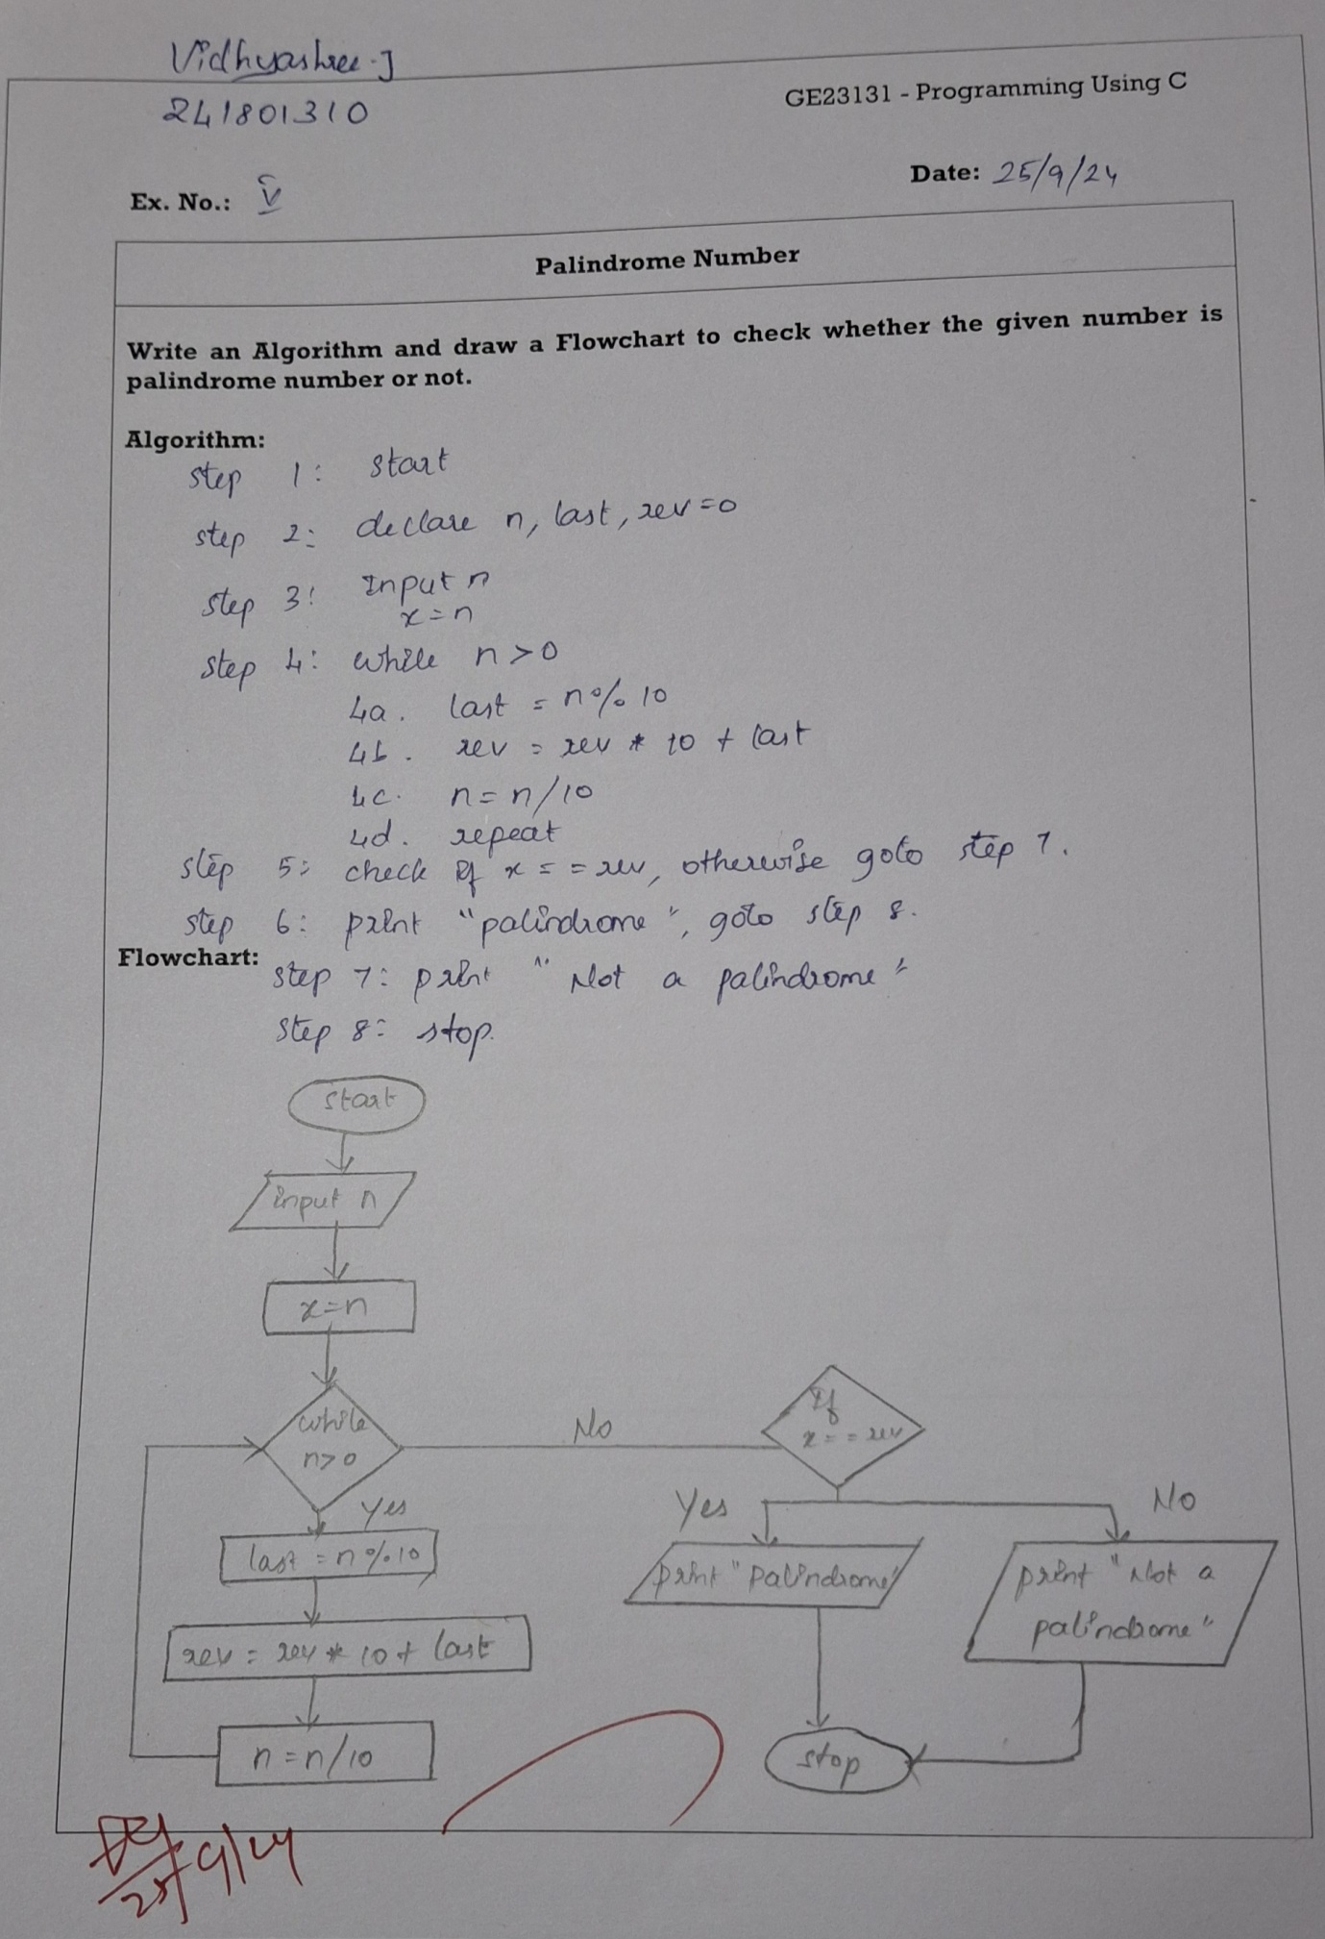

Q6)Sum of digits